SIMULATION EXPERIMENT – 10
Full-Wave Simulation and Optimization of a Microstrip Patch Antenna for Resonant Frequency, Bandwidth, Gain and Radiation-Pattern Enhancement
CO Mapping: CO3
Bloom’s Level: K6 – Create
WK Level: WK4 – Antenna design and optimization

Objectives of this Experiment
- To design a rectangular microstrip patch antenna for a specified microwave operating frequency of 2.4 GHz.
- To investigate the influence of substrate properties and geometrical dimensions on resonant frequency and impedance matching.
- To evaluate VSWR, return loss, bandwidth, radiation pattern, gain, directivity and radiation efficiency from simulated responses.
- To optimize the antenna structure to achieve improved impedance matching and radiation performance.

Expected Outcome from this Experiment
- Design and simulate a rectangular microstrip patch antenna for the specified microwave operating frequency.
- Analyze the influence of substrate properties and antenna dimensions on resonant frequency and impedance matching.
- Evaluate VSWR, return loss, bandwidth, radiation pattern, gain, directivity and radiation efficiency.
- Compare patch-length cases and identify a candidate design based on resonance and impedance-matching requirements.
Software Required: MATLAB for preliminary analytical modelling; CST Studio Suite / Ansys HFSS for full-wave electromagnetic validation.
Objective linkage: Design the patch, study substrate and geometry effects, evaluate impedance and radiation performance, and compare optimized patch lengths against the specified criteria.

Experimental Procedure
A. Antenna Design: Design a rectangular microstrip patch antenna for f0 = 2.4 GHz on an FR-4 substrate with relative permittivity εr = 4.4 and thickness h = 1.6 mm. Use initial dimensions W = 37.2 mm and L = 28.8 mm. Set the simulation sweep from 2.0 to 2.8 GHz.
B. Parameter Study: Vary patch length and substrate properties. Compare the estimated resonant frequency for different lengths and dielectric constants. In CST/HFSS, rerun the electromagnetic simulation for each changed geometry.
C. Performance Evaluation: Obtain S11, VSWR, −10 dB bandwidth, gain, directivity, radiation efficiency and radiation patterns. Determine the resonant frequency and calculate its percentage deviation from 2.4 GHz.
D. Optimization: Compare L = 27.8 mm, 28.8 mm and 29.8 mm. Select the design using the actual simulated resonance, S11, VSWR, bandwidth and radiation performance. Do not mark a requirement as passed unless the simulated data supports it.

Input Parameter Table
S.No. | Input Parameter | Symbol / Setting | Value | Unit
1 | Design frequency | f0 | 2.4 | GHz
2 | Substrate permittivity | εr | 4.4 | —
3 | Substrate thickness | h | 1.6 | mm
4 | Patch width | W | 37.2 | mm
5 | Initial patch length | L | 28.8 | mm
6 | Frequency sweep | fstart–fstop | 2.0–2.8 | GHz
7 | Optimization lengths | L1, L2, L3 | 27.8, 28.8, 29.8 | mm
8 | Return-loss criterion | S11 | ≤ −10 | dB
9 | VSWR criterion | VSWR | ≤ 2 | —
10 | Expected bandwidth | BW at S11 ≤ −10 dB | Typically 60–100 | MHz
11 | Expected gain | G | Approximately 5–7 | dBi

Formulas Used
- Patch width: W = (c / (2f0)) × √(2 / (εr + 1)).
- Effective dielectric constant: εeff = (εr + 1)/2 + [(εr − 1)/2] × [1 + 12h/W]^(−1/2).
- Fringing extension: ΔL = 0.412h × [(εeff + 0.3)(W/h + 0.264)] / [(εeff − 0.258)(W/h + 0.8)].
- Effective patch length: Leff = c / (2f0√εeff). Physical patch length: L = Leff − 2ΔL.
- VSWR = (1 + |Γ|)/(1 − |Γ|), where Γ is the reflection coefficient and |Γ| < 1.
- Return loss: RL = −20 log10|Γ| dB. In an S-parameter simulation, return loss in dB is commonly reported as −S11(dB).
- −10 dB bandwidth: BW = fH − fL, where fL and fH are the frequencies at which S11 crosses −10 dB.
- Percentage frequency deviation = |fr,sim − f0| / f0 × 100%.
- Gain (linear) = radiation efficiency × directivity (linear); gain in dBi is 10log10(Glinear).
- Effective aperture: Ae = Glinear λ0²/(4π), where λ0 = c/f0.

OUTPUTS:
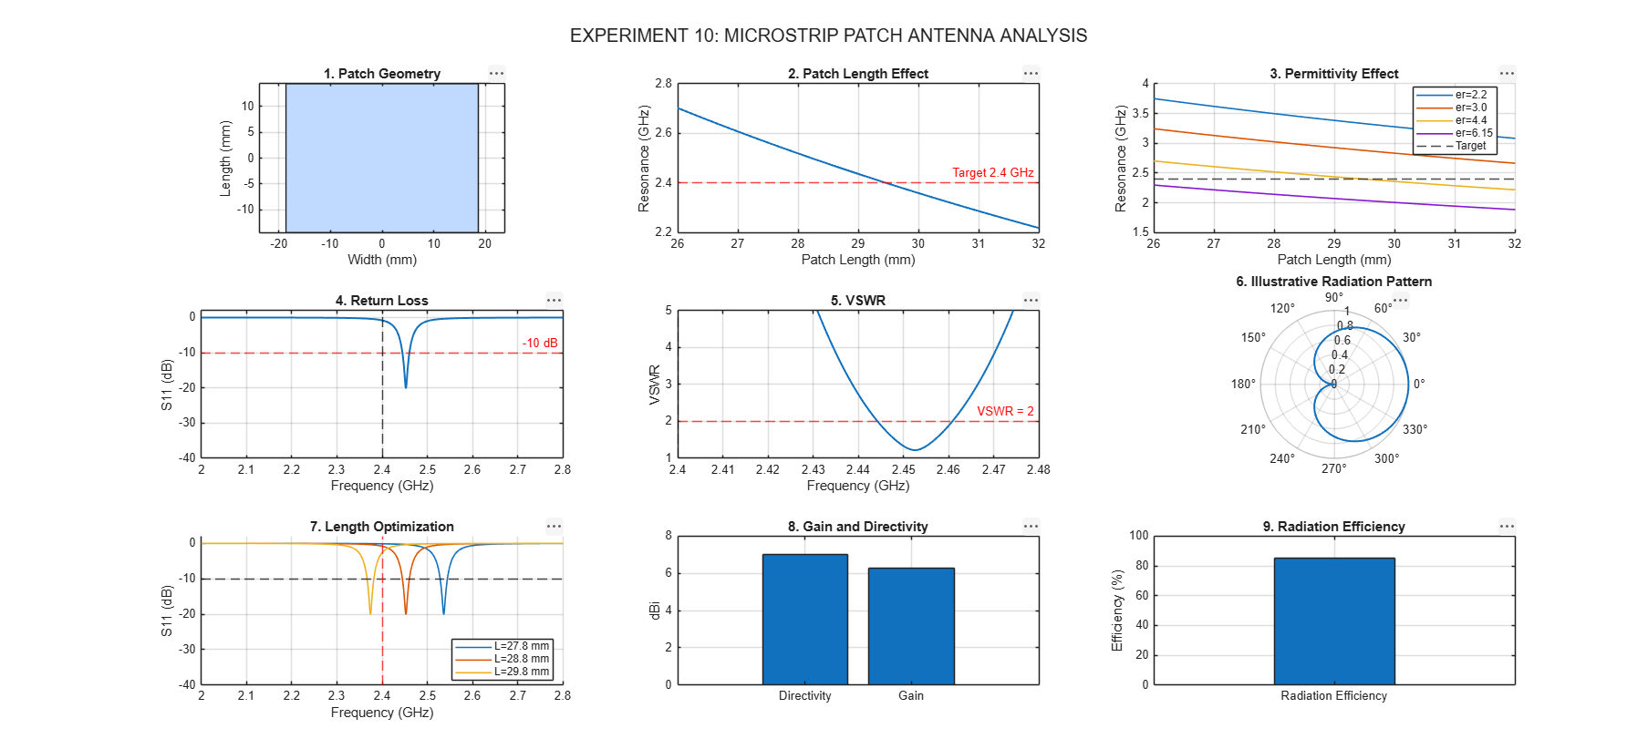
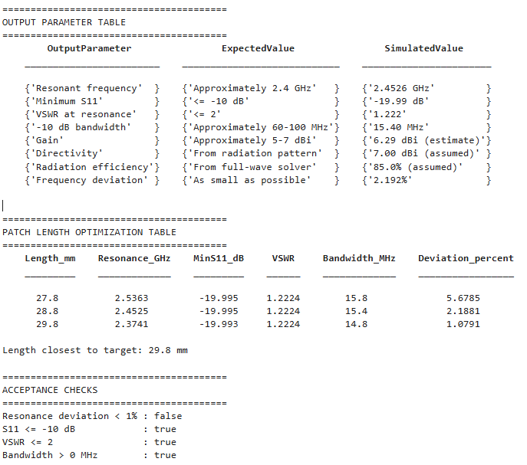

Key Conditions and Threshold Values
Parameter | Requirement / Target | How to Verify
Resonant frequency | Close to 2.4 GHz | Locate the minimum of S11 in the 2.0–2.8 GHz sweep.
Impedance matching | S11 ≤ −10 dB | Read S11 at resonance and at the target frequency.
VSWR | ≤ 2 | Read the VSWR response at the operating frequency.
Bandwidth | Determine −10 dB bandwidth; typical estimate 60–100 MHz | Measure between the two S11 = −10 dB crossings.
Gain | Typically 5–7 dBi depending on design | Obtain realized gain/gain from the full-wave solver.
Directivity | Report simulated value | Obtain from the far-field radiation results.
Radiation efficiency | Report simulated value | Obtain from solver losses and radiation results.
Optimization | Resonance near 2.4 GHz with acceptable S11/VSWR | Compare all three lengths using full-wave results.

Output Parameter Table (to be completed from simulation results)
S.No. | Output Parameter | Theoretical / Expected Value | Simulated Value | % Deviation / Evaluation
1 | Resonant frequency | Approximately 2.4 GHz | Record from S11 minimum | Calculate
2 | Minimum S11 | ≤ −10 dB | Record from solver | Compare with limit
3 | VSWR at resonance | ≤ 2 | Record from solver | Compare with limit
4 | −10 dB bandwidth | Typically 60–100 MHz depending on model | Record from S11 crossings | Calculate
5 | Gain | Approximately 5–7 dBi | Record from far-field results | Compare with expected range
6 | Directivity | From radiation pattern | Record from far-field results | Report
7 | Radiation efficiency | From full-wave solver | Record from solver | Report
8 | Frequency deviation | As small as possible | Calculate from simulated resonance | Calculate
9 | Optimized patch length | One of 27.8, 28.8, 29.8 mm or further optimized | Record selected length | Justify using results

MATLAB Code
The following standalone MATLAB script performs preliminary analytical calculations, creates an illustrative single-resonance S11/VSWR response, compares the three patch lengths, prints parameter tables, and places all nine plots in one 3 × 3 layout. The illustrative response is not a substitute for full-wave electromagnetic simulation; use CST/HFSS to validate actual S-parameters and radiation results.
clc; clear; close all;

%% SIMULATION EXPERIMENT 10: MICROSTRIP PATCH ANTENNA
c = 3e8;
f0 = 2.4e9;
er = 4.4;
h = 1.6e-3;
W = 37.2e-3;
L0 = 28.8e-3;
f = linspace(2e9,2.8e9,4001);

%% Objective 1: theoretical patch calculations
Wcalc = c/(2*f0)*sqrt(2/(er+1));
eeff = (er+1)/2 + (er-1)/2*(1+12*h/W)^(-0.5);
dL = 0.412*h*((eeff+0.3)*(W/h+0.264))/...
((eeff-0.258)*(W/h+0.8));
Leff = c/(2*f0*sqrt(eeff));
Lcalc = Leff - 2*dL;

%% Objective 2: patch length, thickness and permittivity effects
Lsweep = linspace(26e-3,32e-3,201);
frL = c./(2*(Lsweep+2*dL)*sqrt(eeff));

hsweep = [0.8 1.0 1.6 2.0 2.4]*1e-3;
frh = zeros(size(hsweep));
for k = 1:numel(hsweep)
hk = hsweep(k);
et = (er+1)/2 + (er-1)/2*(1+12*hk/W)^(-0.5);
dt = 0.412*hk*((et+0.3)*(W/hk+0.264))/...
((et-0.258)*(W/hk+0.8));
frh(k) = c/(2*(L0+2*dt)*sqrt(et));
end

erSweep = [2.2 3.0 4.4 6.15];
frer = zeros(numel(erSweep),numel(Lsweep));
for k = 1:numel(erSweep)
ert = erSweep(k);
et = (ert+1)/2 + (ert-1)/2*(1+12*h/W)^(-0.5);
dt = 0.412*h*((et+0.3)*(W/h+0.264))/...
((et-0.258)*(W/h+0.8));
frer(k,:) = c./(2*(Lsweep+2*dt)*sqrt(et));
end

%% Objective 3: illustrative S11 and VSWR response
% Illustrative model only; actual response requires CST/HFSS.
fr0 = c/(2*(L0+2*dL)*sqrt(eeff));
Q = 25;
GammaMin = 0.1;
x = 2*Q*(f/fr0-fr0./f);
Gamma = (GammaMin+1i*x)./(1+1i*x);
S11dB = 20*log10(abs(Gamma));
VSWR = (1+abs(Gamma))./(1-abs(Gamma));

[~,iRes] = min(abs(f-fr0));
frSim = f(iRes);
S11min = S11dB(iRes);
VSWRres = VSWR(iRes);
idx = find(S11dB <= -10);
if isempty(idx)
BW = NaN; fL = NaN; fH = NaN;
else
fL = f(idx(1)); fH = f(idx(end));
BW = (fH-fL)/1e6;
end
freqDev = abs(frSim-f0)/f0*100;

%% Gain/directivity/efficiency placeholders
% Replace these assumed values with CST/HFSS outputs.
D_dBi = 7.0;
eta = 0.85;
Dlin = 10^(D_dBi/10);
Glin = eta*Dlin;
G_dBi = 10*log10(Glin);
lambda0 = c/f0;
Ae = Glin*lambda0^2/(4*pi);

%% Objective 4: compare L = 27.8, 28.8 and 29.8 mm
Lcases = [27.8 28.8 29.8]*1e-3;
n = numel(Lcases);
frCases = zeros(n,1); S11Cases = zeros(n,1);
VSWRCases = zeros(n,1); BWCases = zeros(n,1);
devCases = zeros(n,1); S11curves = zeros(n,numel(f));

for k = 1:n
Lk = Lcases(k);
frCases(k) = c/(2*(Lk+2*dL)*sqrt(eeff));
xk = 2*Q*(f/frCases(k)-frCases(k)./f);
Gk = (GammaMin+1i*xk)./(1+1i*xk);
sk = 20*log10(abs(Gk));
vk = (1+abs(Gk))./(1-abs(Gk));
S11curves(k,:) = sk;
[S11Cases(k),ik] = min(sk);
VSWRCases(k) = vk(ik);
ibw = find(sk <= -10);
if isempty(ibw)
BWCases(k) = NaN;
else
BWCases(k) = (f(ibw(end))-f(ibw(1)))/1e6;
end
devCases(k) = abs(frCases(k)-f0)/f0*100;
end

%% Output tables
InputParameter = {'Design frequency'; 'Relative permittivity'; ...
'Substrate thickness'; 'Patch width'; 'Initial patch length'; ...
'Frequency sweep'; 'Optimization lengths'};
InputValue = {'2.4 GHz'; '4.4'; '1.6 mm'; '37.2 mm'; ...
'28.8 mm'; '2.0-2.8 GHz'; '27.8, 28.8, 29.8 mm'};
disp(table(InputParameter,InputValue));

OutputParameter = {'Resonant frequency'; 'Minimum S11'; 'VSWR'; ...
'-10 dB bandwidth'; 'Gain (estimate)'; 'Directivity (assumed)'; ...
'Radiation efficiency (assumed)'; 'Frequency deviation'};
Expected = {'~2.4 GHz'; '<= -10 dB'; '<= 2'; 'Typically 60-100 MHz'; ...
'Typically 5-7 dBi'; 'From full-wave pattern'; ...
'From full-wave solver'; 'As small as possible'};
Simulated = {sprintf('%.4f GHz',frSim/1e9); sprintf('%.2f dB',S11min); ...
sprintf('%.3f',VSWRres); sprintf('%.2f MHz',BW); ...
sprintf('%.2f dBi',G_dBi); sprintf('%.2f dBi',D_dBi); ...
sprintf('%.1f%%',eta*100); sprintf('%.3f%%',freqDev)};
disp(table(OutputParameter,Expected,Simulated));

OptimizationTable = table(Lcases'*1e3,frCases/1e9,S11Cases,...
VSWRCases,BWCases,devCases,'VariableNames',...
{'Length_mm','Resonance_GHz','MinS11_dB','VSWR',...
'Bandwidth_MHz','Deviation_percent'});
disp(OptimizationTable);

%% Illustrative normalized radiation pattern
theta = linspace(0,2*pi,721);
R = abs(cos(theta/2));
R = R/max(R);

%% All nine figures in one 3x3 layout
figure('Color','w','Name','Experiment 10: Antenna Analysis',...
'NumberTitle','off','Position',[20 40 1500 900]);

subplot(3,3,1);
px = [-W/2 W/2 W/2 -W/2]*1e3;
py = [-L0/2 -L0/2 L0/2 L0/2]*1e3;
fill(px,py,[0.75 0.85 1]); axis equal; grid on;
xlabel('Width (mm)'); ylabel('Length (mm)');
title('1. Patch Geometry');

subplot(3,3,2);
plot(Lsweep*1e3,frL/1e9,'LineWidth',1.4); hold on;
yline(f0/1e9,'r--'); grid on;
xlabel('Patch length (mm)'); ylabel('Resonance (GHz)');
title('2. Patch Length Effect');

subplot(3,3,3);
hold on;
for k = 1:numel(erSweep)
plot(Lsweep*1e3,frer(k,:)/1e9,'LineWidth',1.1);
end
yline(f0/1e9,'k--'); grid on;
xlabel('Patch length (mm)'); ylabel('Resonance (GHz)');
title('3. Permittivity Effect');
legend('er=2.2','er=3.0','er=4.4','er=6.15','Target',...
'Location','best');

subplot(3,3,4);
plot(f/1e9,S11dB,'LineWidth',1.4); hold on;
yline(-10,'r--'); xline(f0/1e9,'k--'); grid on;
xlabel('Frequency (GHz)'); ylabel('S11 (dB)');
title('4. Return Loss'); ylim([-40 2]);

subplot(3,3,5);
plot(f/1e9,VSWR,'LineWidth',1.4); hold on;
yline(2,'r--'); xline(f0/1e9,'k--'); grid on;
xlabel('Frequency (GHz)'); ylabel('VSWR');
title('5. VSWR'); ylim([1 5]);

subplot(3,3,6);
polarplot(theta,R,'LineWidth',1.4);
title('6. Illustrative Radiation Pattern');

subplot(3,3,7);
hold on;
for k = 1:n
plot(f/1e9,S11curves(k,:),'LineWidth',1.1);
end
yline(-10,'k--'); xline(f0/1e9,'r--'); grid on;
xlabel('Frequency (GHz)'); ylabel('S11 (dB)');
title('7. Patch Length Optimization');
legend('L=27.8 mm','L=28.8 mm','L=29.8 mm',...
'Location','best'); ylim([-40 2]);

subplot(3,3,8);
bar([D_dBi G_dBi]);
set(gca,'XTickLabel',{'Directivity','Gain'});
ylabel('dBi'); grid on;
title('8. Gain and Directivity');

subplot(3,3,9);
bar(eta*100); set(gca,'XTickLabel',{'Efficiency'});
ylabel('Efficiency (%)'); ylim([0 100]); grid on;
title('9. Radiation Efficiency');

sgtitle('Experiment 10: Microstrip Patch Antenna Analysis');

fprintf('\\nTheoretical width = %.2f mm\\n',Wcalc*1e3);
fprintf('Theoretical length = %.2f mm\\n',Lcalc*1e3);
fprintf('Estimated resonance = %.4f GHz\\n',frSim/1e9);
fprintf('Estimated S11 = %.2f dB; VSWR = %.3f; BW = %.2f MHz\\n',...
S11min,VSWRres,BW);
fprintf('Frequency deviation = %.3f %%\\n',freqDev);
fprintf('Effective aperture estimate = %.3f cm^2\\n',Ae*1e4);
fprintf('Reminder: validate all RF and radiation values in CST/HFSS.\\n');

Result
The rectangular microstrip patch antenna is defined for a 2.4 GHz target using an FR-4 substrate with εr = 4.4 and h = 1.6 mm. The MATLAB script calculates theoretical dimensions and estimated resonance, studies parameter variations, generates illustrative S11 and VSWR curves, and compares the three specified patch lengths. Actual simulated values must be obtained from CST/HFSS and entered into the output table.

Conclusion
This experiment demonstrates the preliminary design and optimization workflow for a rectangular microstrip patch antenna. Patch length, substrate permittivity and substrate thickness affect the resonant frequency. The final antenna must be selected using full-wave simulation results for resonant frequency, S11, VSWR, bandwidth, gain, directivity, radiation efficiency and radiation pattern. Any unmet acceptance criterion should be reported honestly and addressed through further optimization.

Reflection
The experiment helped develop an understanding of rectangular microstrip patch antenna design and the effect of substrate and geometrical parameters on resonance. Comparing different patch lengths illustrates the optimization process. Full-wave validation is necessary to confirm impedance matching and radiation performance.
Important modelling note: The MATLAB S11/VSWR response and radiation-pattern plot in this document are illustrative models. Gain, directivity and efficiency are assumed placeholders. They must not be presented as measured or full-wave simulated results. Use CST/HFSS results for final validation.

